INSTRUCTION MANUAL FOR DSB-500D & DSB-1000D
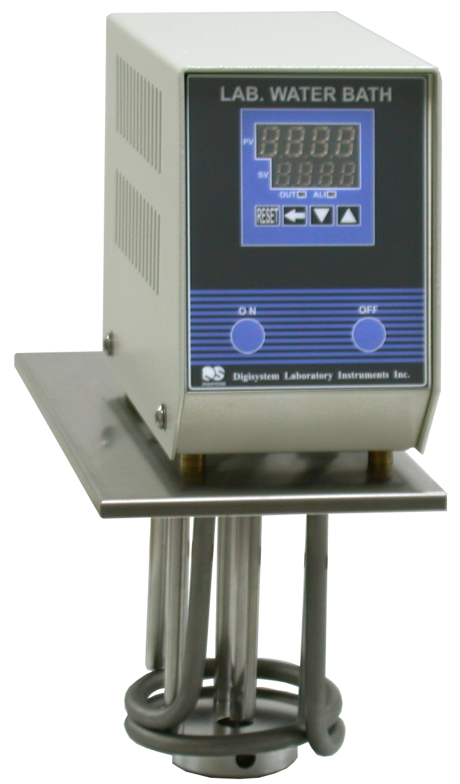
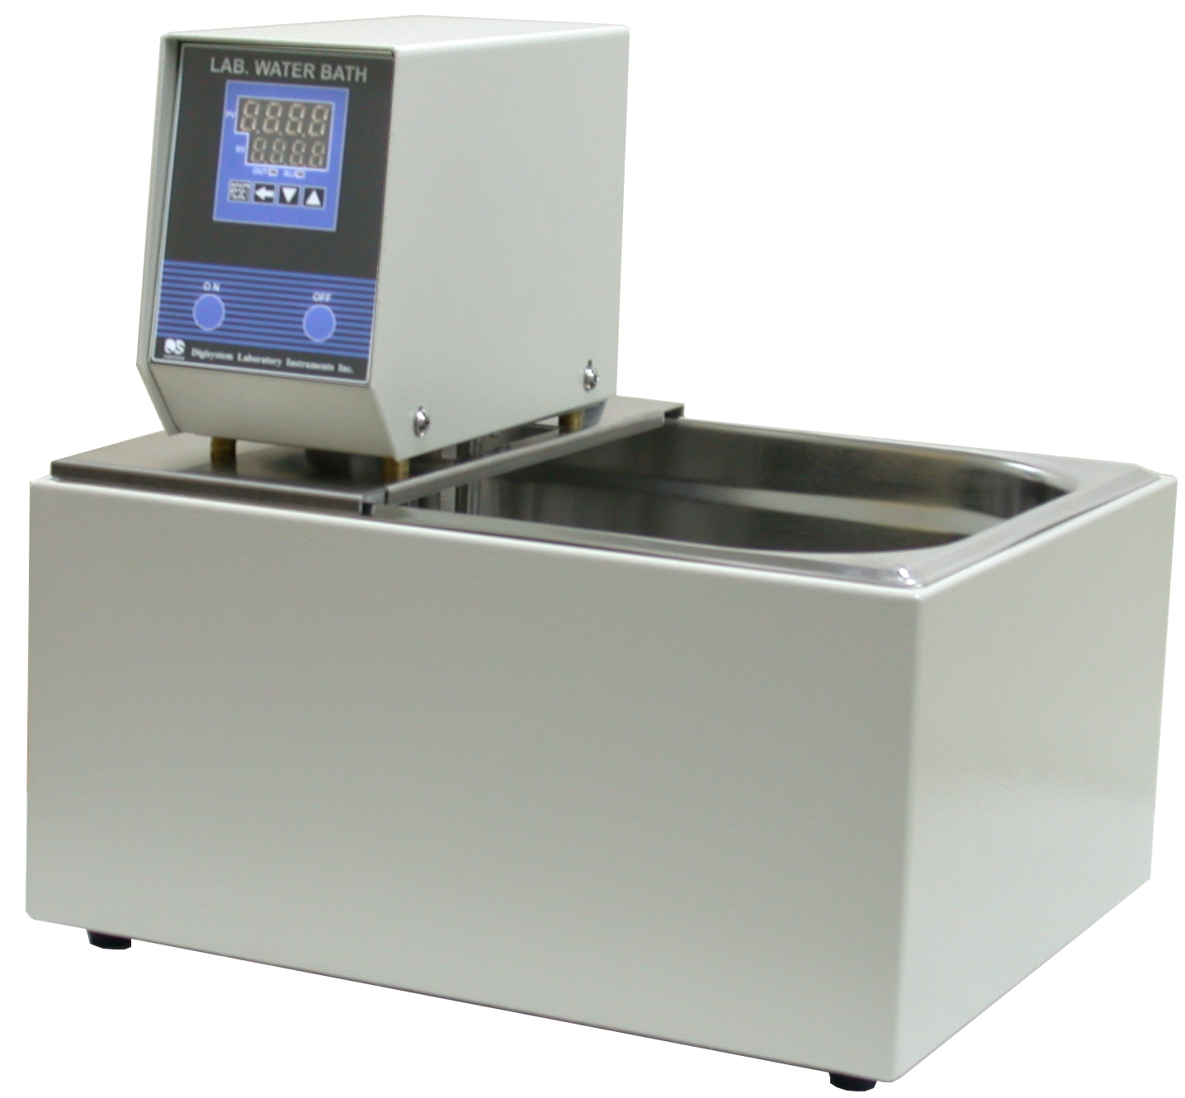
(1)

(5)

Figure 2
(3)
(4)

(2)
(6)

Figure 1
(7)

Name of parts:
(1) Controller (2) Tank
(3) ON/OFF button (4) Power indicator
(5) PID Controller (6) Heater
(7) Pump Circulator

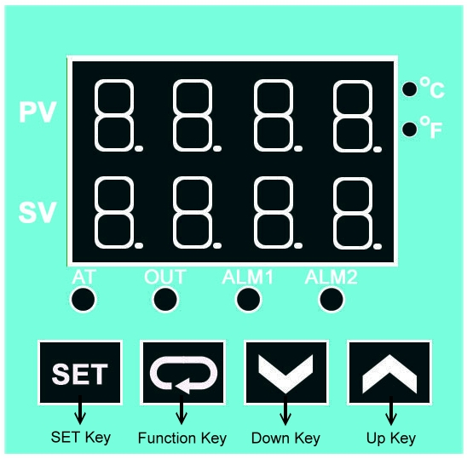
Steps:
1. Take “Controller” (1) out and set it into “Tank” (2) as Figure 1
2. Pour water into “Tank” until water level covers half height of “Tank”.
3. Connect with power supply. Please make sure the power voltage is the same as the voltage showing on the label stuck on the back of machine.You may see the “Power indicator’ (4) become red.
4. Press “ON/OFF Button”(3), then you may see the “Power indicator’ (4) become green. Wait for about 5 seconds; you can see from PID control panel the present temperature value (PV) in upper row and setting temperature value (SV) in lower row.
5. Press “Up Key” or “ Down Key” to adjust SV value and then press “SET Key” to enter the value.
6. After finishing the work, please press “ON/OFF Button” (3) to turn off the power, and then the “Power indicator’ (4) become red.

Warning:
If water level is under the bottom of “Heater” (6), you must pour water into “Tank” to cover the heater. With the built-in over heating device, if the temperature is over 120℃, the power will be cut automatically.

Other functions:
Note: Before executing other functions, please follow “5. Setting lock” ( c )to release “LOCK” status.
After executing other functions, please follow “5. Setting lock” to set “LOCK” status.
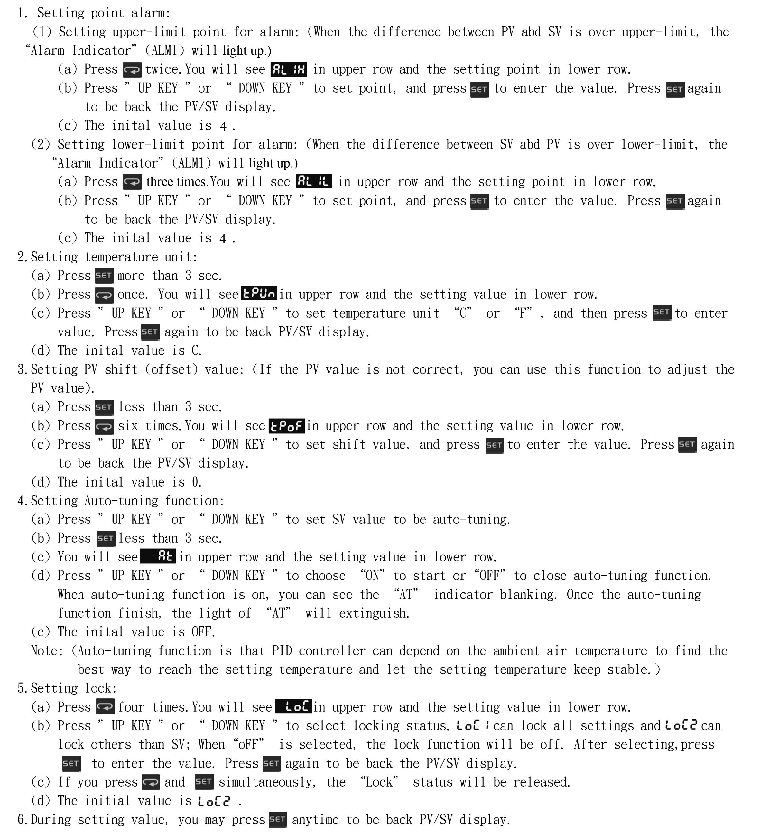

SERVICE MANUAL
Caution: Always disconnect the power cord before troubleshooting.
Trouble | Cause | Remedy
Instrument inoperative | Power cord not connected to outlet. | Plug instrument in..
Instrument inoperative | Dead power output. | Change to different output.
Instrument inoperative | Current is overload, so the no fuse breaker on the behind of the controller | Push the button of the no fuse breaker to reset
Controller can’t control the water temperature | Sensor is broken | Replacing a sensor
Controller can’t control the water temperature | PID controller | Replacing a PID controller
Controller can’t control the water temperature | Heater is broken | Replacing a heater
Pump Circulator doesn’t work well | Pump Circulator is broken | Replacing a Pump Circulator
Pump Circulator doesn’t work well | Foreign bodies blockaged the pump Circulator | Sweep away the foreign bodies
The key of PID controller can’t work | The keys has been locked | Please refer to page 2, Other functions 5. (c) to release the lock status.
Temperature is not stable | The initial setting value is not suitable for the ambient air temperature where the machine is located | Please refer to page 2, Other functions 4. to set auto-tuning function to solve this problem.
PV value is not correct | User’s calibration thermometer is different from the factory’s calibration thermometer | Please refer to page 2, Other functions 3 to adjust PV value

CIRCUIT DIAGRAM

